

Faculty of Science, Engineering and Technology

Computer Systems
Week 6

Overview
I n t h i s l a b o r a t o r y y o u w i l l b e w o r k i n g o n y o u r a s s i g n m e n t
^{Purpose:} To begin planning and get feedback/help on your assignment
Task:
^{Time:} This lab is due by the start of your week 6 lab.
^{Assessment:} This lab is worth 1% of your assessment for this unit, and only if demonstrated to your lab demonstrator in the week it is due.
^{Resources:} ■ Assignment Handout (download from Canvas) ■ All previous resources
Submission Details
You must submit the following files to Canvas:
■ A document containing all required work as described below.

Computer Systems Week 6 Laboratory

Instructions
Working on your assignment
- Work on your assignment
- What is the most challenging component of the assignment ? Be as specific as possible.
- Discuss this answer, and your progress, with your lab demonstrator
- Document your progress so far and plans
---
Progress Report – Digital Stopwatch Project
1. Work on the Assignment
Up to this point, I have completed the full Digital Stopwatch system, including:
- Master Control (Start/Stop using T Flip-Flop)
- Stage 2 & 3: Seconds counter
- Stage 4: Minutes counter with customised reset (Student ID)
- Stage 5: Split function limited to 5
- Integration of 5 Split Time displays into the main circuit
The system is now fully functional and operates according to the assignment requirements.
2. Most Challenging Components
Challenge 1 – Stage 4: Reset to Student ID
The first major challenge was designing the reset function to display my Student ID value (08).
Initially, I experimented with different methods by controlling the D inputs through various logic gate combinations. However, these approaches were unstable and not optimal.
I revisited the theory of Flip-Flops, especially the relationship between the Set (S) input in JK Flip-Flops and the output Q. After reviewing the definitions and testing different configurations, I successfully implemented a stable and optimized reset mechanism that correctly loads the Student ID value without further issues.
Challenge 2 – Split Limit to 5
At first, I used JK Flip-Flops to create the Split counter limited to 5. However, this design required many logic gates and became unnecessarily complex.
I then redesigned the system using D Flip-Flops combined with a NAND gate to detect the limit condition. I also used an AND gate to combine the Split button signal with the limit logic.
This new design was cleaner, more efficient, and successfully restricted the Split function to a maximum of five times.
Challenge 3 – Implementing Additional 4 Split Time Displays
Initially, I directly reused the Stage 5 circuit in the main system to display the additional Split Times. Although the circuit worked, it produced incorrect values. The display exceeded 9 and showed hexadecimal outputs (A, B, C, … F).
After checking wiring and clock directions without success, I discovered that during the first Split, the four additional Split displays automatically loaded the previous reset value (08:00), which caused incorrect behavior.
I attempted to redesign the circuit using additional D logic, but it became too long and inefficient.
After reviewing Week 6 material, I recalled the concept of Registers for parallel data storage. I redesigned the Split Time system using a register-based memory approach instead of duplicating the counter circuit.
This final solution worked correctly and stabilized the Split storage mechanism.
3. Current Progress
At this stage:
- The stopwatch runs correctly
- Reset loads the correct Student ID value
- Split is limited to 5 presses
- All 5 Split Time displays store data properly
- No overflow or hexadecimal display errors remain
The system is complete and ready for submission.
4. Future Plan
Before final submission, I plan to:
- Perform additional stability testing
- Verify timing accuracy under continuous operation
- Recheck wiring structure for clarity and optimization
- Prepare final screenshots and documentation for Canvas submission
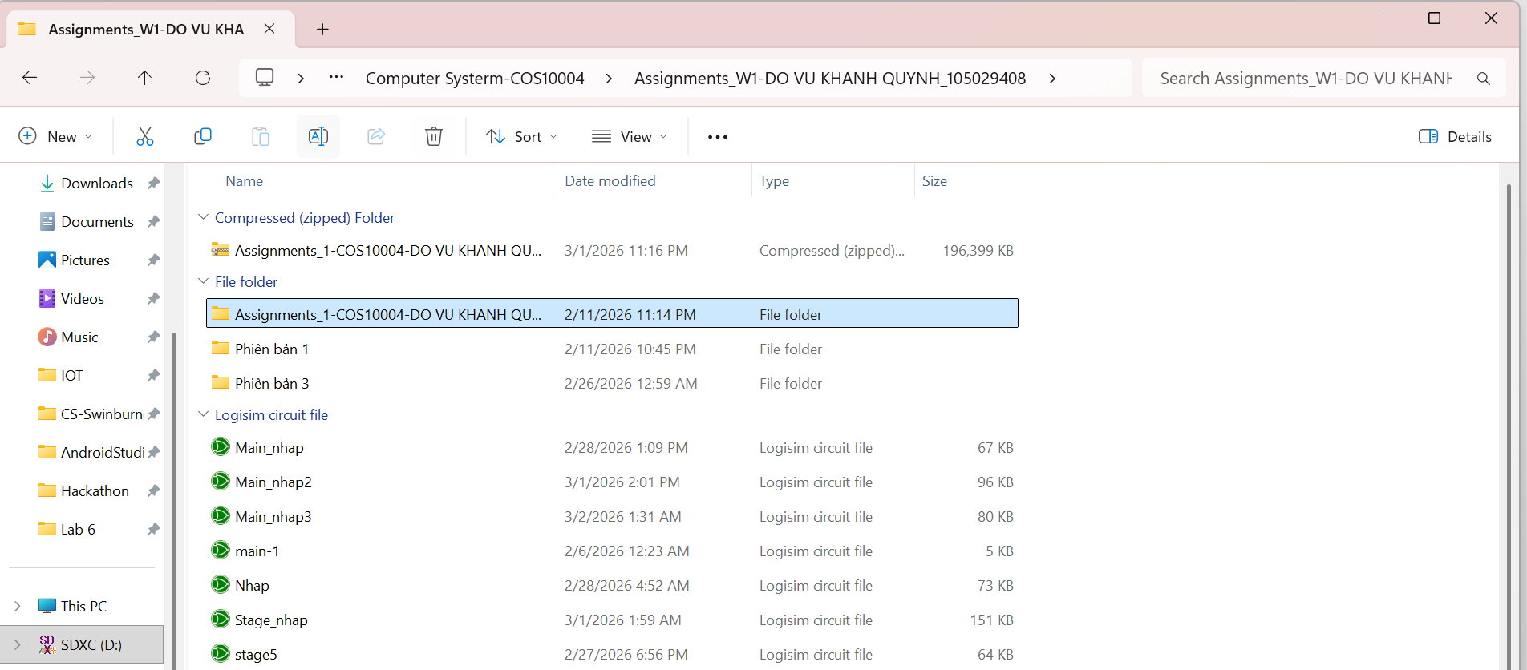
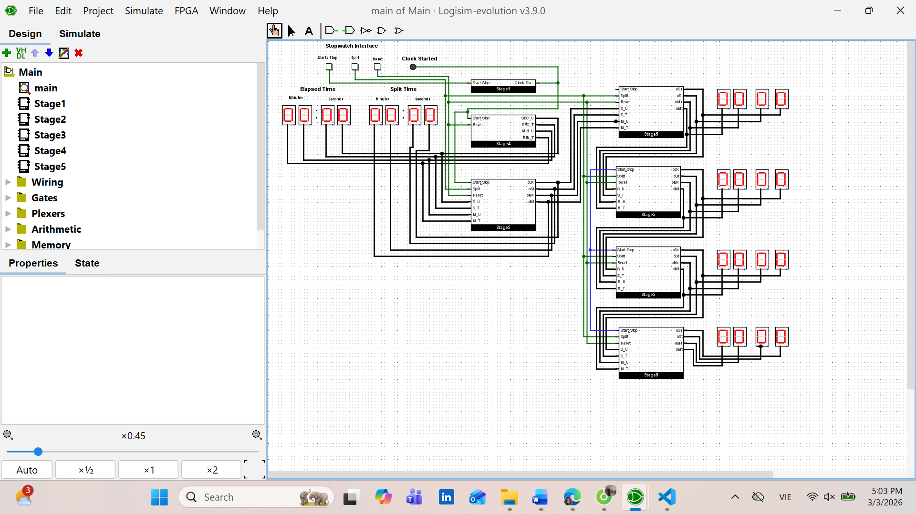
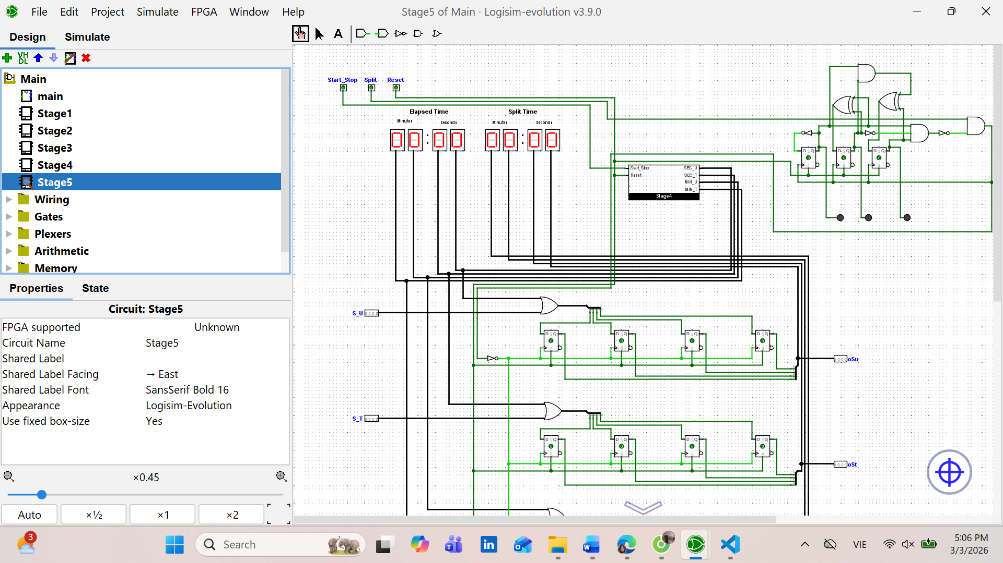
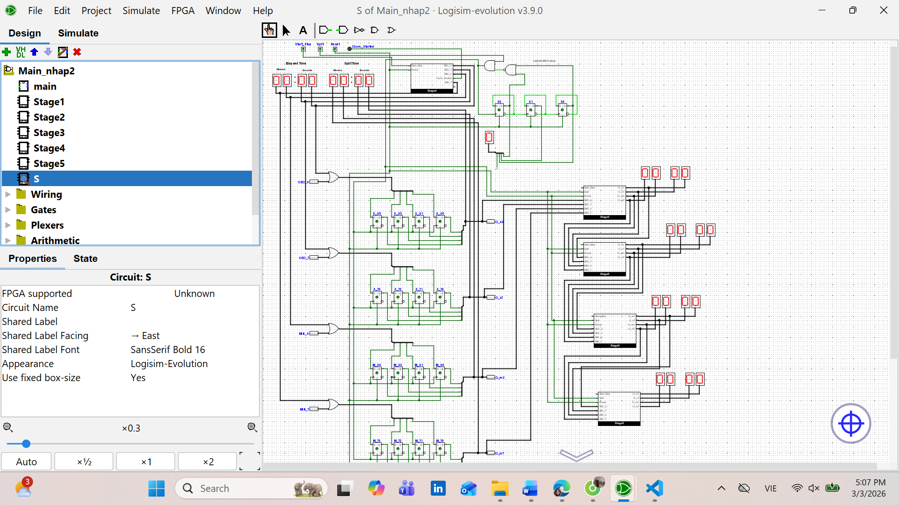
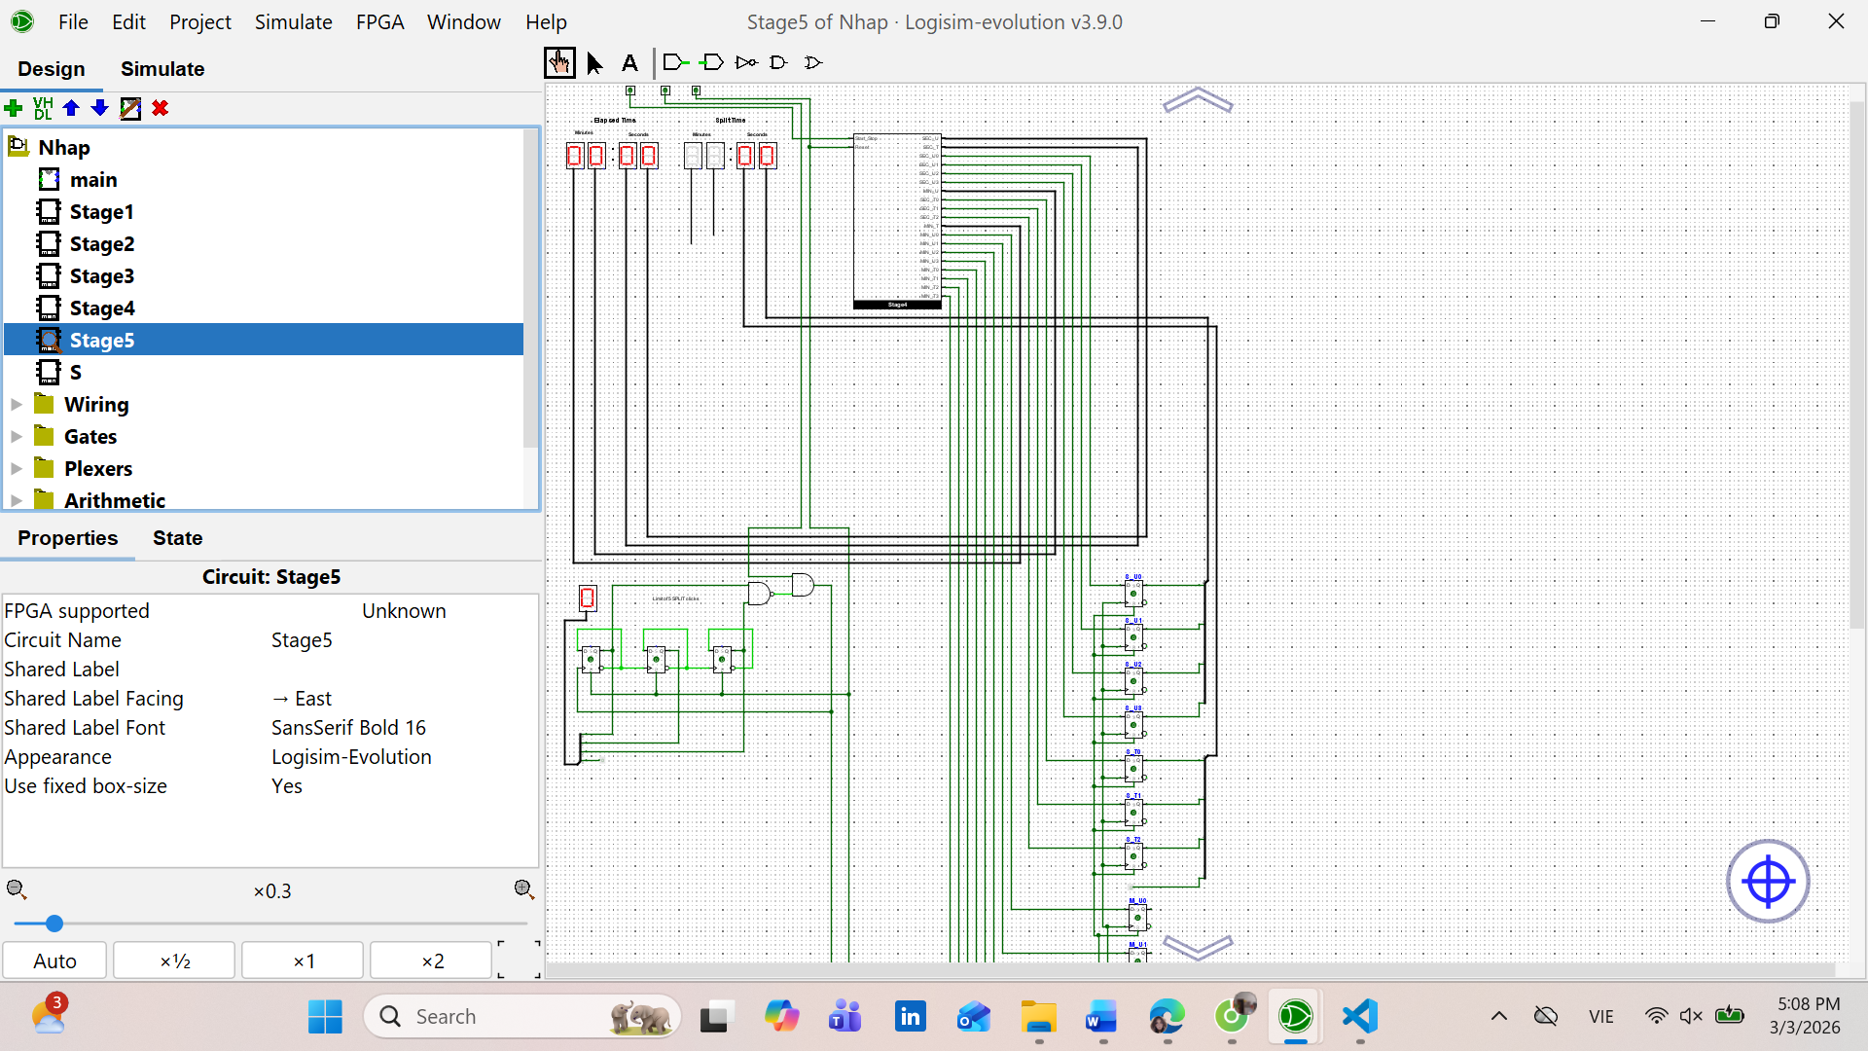
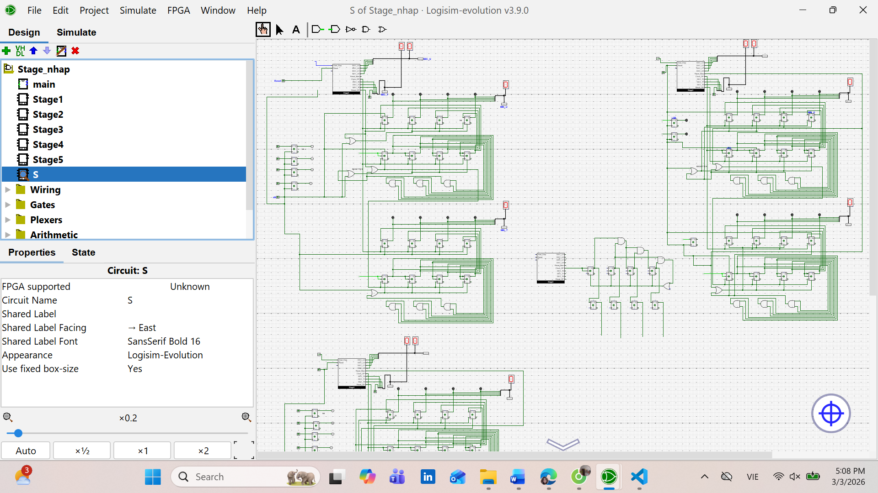
Export a document of evidence of your progress to date, including images of notes/ screen shots and any other notes.
When complete:
■ Submit your answers (screen shots, etc) in a single document using Canvas
■ Show your lab demonstrator your working circuits in class (you must do this to get the 1%). Your lab demonstrator may request you to resubmit if issues exist.
Page 2 of 2

